11AC 600Mbps Nano-Sized Wireless USB Adapter
WL-AC-600M

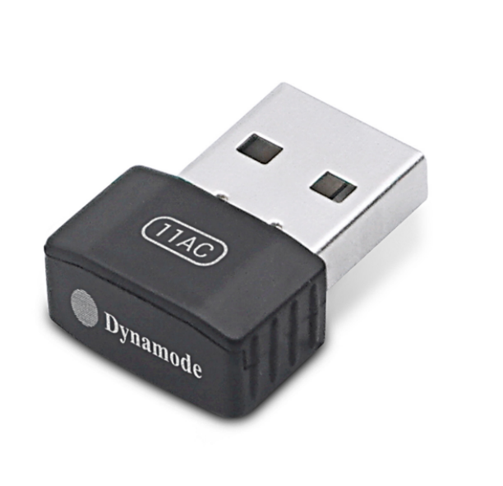

Descrption:
The new, nano-sized WL-AC-600M is a high-performance, dual-band WiFi USB adapter for both WindowsTM and MacTM OS X that offers congestion-free, high-speed WiFi capabilities for the next generation applications including HD movie streaming, online gaming and more.
Offering a combined WiFi speed of up to 600Mbps, via automatically connecting to your broadband router or access point at either 2.4Ghz or 5Ghz. The latest 5Ghz band makes use of less WiFi congestion than regular WiFi clients, even in a busy office environment.

Features:
- Dual-band 802.11AC WiFi connectivity
- 2.4Ghz and 5.0Ghz congestion free WiFi
- Up to 600Mbps WiFi communications
- Enhanced WiFi Encryption to keep signals safe
- Ideal for current, future and existing WiFi Routers etc
- Plug n' Play for WindowsTM, MacTM OS X and LinuxTM

SPECIFICATIONS:
- Standards：IEEE 802.11ac, 11a, 11n, 11g, 11b
- Wireless Signal Rates With Automatic Fallback：11ac: Up to 433Mbps(Dynamic)
- 11n: Up to 150Mbps (Dynamic) 11g: Up to 54Mbps (Dynamic) 11b: Up to 11Mbps (Dynamic)
- Frequency Range：2.4-2.4835GHz/4.92-5.945GHz
- Channel：1-13
- Wireless Transmit Power：18dBm (EIRP)
- Modulation Type：DBPSK,DQPSK,CCK, OFDM
- Receiver Sensitivity：433M:-53dBm@10%PER 150M: -68dBm@10% PER
- 54M: -72dBm@10% PER 11M: -85dBm@8% PER
- Work Mode：Ad-Hoc Infrastructure ,soft AP
- Wireless Security：WPS,64/128bit WEP, WPA/WPA2, WPA-PSK/WPA2-PSK(TKIP/AES)
- Support Operating System：Windows Vista/Win7/Win8/Win10/Linux/Mac OS
- Interface：USB2.0 Hi-Speed connector
- Antenna Type：Internal Omni-directional Antenna
- Weight：2.5g
- Dimensions：16.6mm×22.3mm×8.5mm
- Operating Temperature：0°C~40°C (32°F~104°F)
- Storage Temperature：-40°C~70°C (-40°F~158°F)
- Relative Humidity：10% ~ 90%, non condensation
- Storage Humidity: 5%~95% non-condensing

